|  |
| --- |
| 新东方在线英语学习 |
| 新概念 1 册 |
| Lesson33-34 |



扫一扫。更多有趣的英语资讯。

# Lesson 33 单词讲解

1. day：日子、天today，今天yesterday，昨天、holiday，假日
2. cloud：云

天空中飘着几朵云。

There are some clouds in the sky.

1. sky: 天空

in the sky

4 . sun

# Sunhat sunglass sunblock

1. shine : 照耀shi ai n yi

The sun is shining. 阳光灿烂。Shi ai ning

1. with：和…在一起

He is with his new girlfriend. 他和他的新女朋友在一起。

I am with my new sunglass. 我带着我的新墨镜。The house is with a garden. 这栋房子带着一个花园。人与人，人与物，物与物

1. family：家庭

a family meeting 家庭会议

We are a family. 我们是一家人。

Are you the family of…? 你们是…的家属吗？

1. walk：走路，步行

I walk to school. 我步行上学。

1. over：跨越、上方

He is walking over the bridge. 他正走着跨过那座桥。

The bird is flying over the river.

1. bridge：桥

过桥 —— over the bridge

他正在过桥。—— He is overing the bridge. He is going\walking\running over the bridge.

1. boat：小船

dream boat 梦中情人

1. river：河
2. ship：轮船
3. aeroplane：飞机
4. fly： 飞
5. 描述天气：it 作主语

# Lesson 33 课文讲解

今天天气很好。It is fine today.

春天天气很糟糕。 It is bad in spring.

夏天天气很好。It is nice in summer.

描述天气的句型结构： it is+ adj.+ 时间

1. …is with his family.

with: 介词，动词+ 介词The desk near the window.

The desk is near the window. She with her friends.

She is with her friends.

课文仿写：

今天的天气真好。天空中飘着几朵白云，但是阳光灿烂。

It is fine today. There are some clouds in the sky. But the sun is shining. Lucy 和她的男朋友在一块儿。他们正在开车。Lucy 正在看



Lucy is with her boyfriend. They are driving.

一只漂亮的小鸟。小鸟正从天上飞过。一些人从天桥上走Lucy is looking at a beautiful bird. The bird is flying in the sky. 过，他们很忙。

Some people are walking over the bridge. They are busy.

# Lesson 33 语法讲解

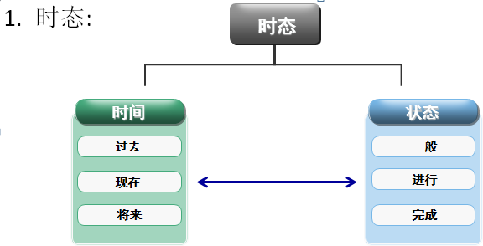

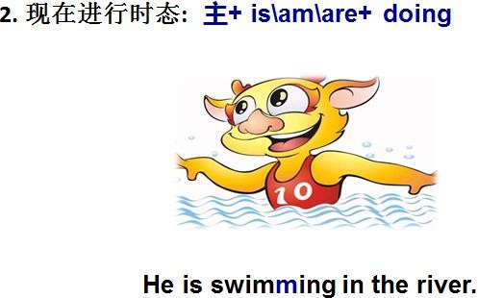

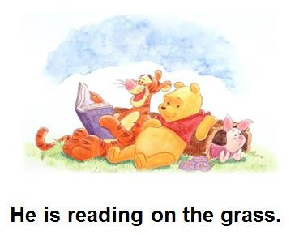



**Lesson 34 单词句型讲解**

1. sleep: 睡觉
2. shave: 刮胡子

shaver 刮胡刀

1. cry: 哭ke rua ai

The baby is crying.

1. wash: 洗

wash my face\ wash your hands

1. wait: 等待

wait for me 等等我

look at listen to wait for

# Lesson 33&34 知识拓展

